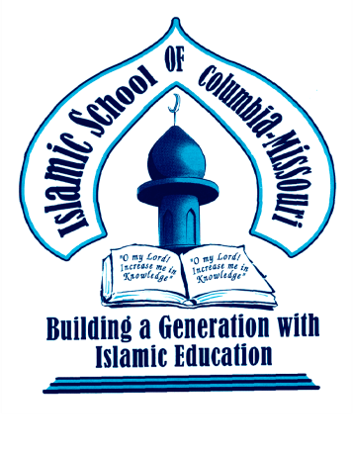
Islamic School of Columbia- Missouri
408 Locust Street Columbia, MO 65201 Telephone:(573)442-1556 Fax:1-800-531-8816
Email: iscmschool@gmail.com
Pledge Form
“And whatsoever you spend of anything (in Allah's Cause), He will replaceit.''
Al Quran 34:39

Dear Respected Community Member,

Thank you for making a pledge to the Islamic School of Columbia-MO. All donors are deeply appreciated. Pledges are not only welcome through personal checks, we are now accepting donations through our PayPal account, accessible through our school website at www.theiscm.org under the tab title “Donate”.
----------------------------------------------------------------------------------------------------------------------------
I would love to help! Please accept this donation of:

General Pledge to Islamic School of Columbia-MO

Monthly Pledge One Time Pledge

$5000 $2500 $1000 $500 $250 $100 $50 $25 $10 Other

Specific Pledge for our programs

Monthly Pledge One Time Pledge
$5000 $2500 $1000 $500 $250 $100 $50 $25 $10 Other

Please circle the program you would like to support with your donation

- Haafiz Scholarships
- *Adopt a Student $5,000/yearly $500/monthly
- Low-incomeScholarships$2500 $1,000 $500 $100
- Textbooks
- Technology- Set of 10 ipads for students
- Summer Expenses
- Merit for Teachers

*Adopt a Student Endowment Name Would you like to be updated on the student’s progress? Yes No

Automatic Monthly Withdrawal

I give the Islamic School of Columbia-Missouri my permission to withdraw the monthly pledge I have checked here from my bank account, unless I send a written notice of any change or termination.

Please include a voided check with your pledge.

Name: Telephone: E-mail: Address:

City:
State:
Zip:

Account Number (Please include routing#): BankName: Signature: Date:

All donations are tax deductible. Tax ID # 16 - 1745888

May Allah (SWT) bless of what you spend and what you keep.
Ameen.

