Pre k School Supplies List
2018-2019 School Year

• 1 School box
• 1-inch 3-ring binder with showcase view for prek 4 only
• 2 pocket folder just one only
• 1 box of markers
• 2 Elmer’s (glue all)
• 3 glue sticks
• 2 Big bottle of hand sanitizer
• 3 boxes of wipes
• 3 boxes of Kleenex
• 3 rolls of paper towels
• 1 box of play dough
• 1 package of construction paper
• Bottle of paint (ask the teacher for more information before you buy)
• Small blanket/sheet
• Small pillow
• Kinder Mat/ Nap Mat
• Extra clothes including socks and shoes.
*This supplies used for both the Arabic and English teacher
*Please ask the teacher for specific information before you buy

KG School Supply List 2018-2019
(Supplies will be used in both homeroom and Arabic class.)

Label with child’s name:

* Backpack, full size that will hold an 8½ x 11 folder
* 1 Crayola watercolor set

Do not label the following items – the class will share:

* 3 poly vinyl folders with center brads (1 red, 1 blue, 1 purple)
* 10 #2 pencils
* 1 pink eraser
* 8 glue sticks
* 4 dry erase markers (2 fine tip, 2 chisel tip)
* 1 box washable markers
* 1 package card stock (white)
* 3 containers of Play-Doh
* 2 tissue boxes
* 1 package of disinfecting wipes (girls only)
* 1 Ziploc box sandwich size (girls only)
* 1 package of baby wipes (boys only)
* 1 Ziploc box snack size (boys only)

Arabic Supplies List
- 1package card stock paper (white)
- 1package card stock paper (color)

First Grade School Supplies List
2018-2019 School Year
***MUST have by August 10th (Back to School Night/Supply Drop off)***
Please label the following:
1 backpack Agenda: please go to Amazon.com and purchase
1” 3-ring binder with showcase view this agenda book:
1 box of Crayola washable markers
Amazon.com: Undated Student Planner for Elementary Kids - Assignment Agenda - By School Datebooks : Office Products
https://www.amazon.com/gp/aw/d/B01LX0BY02/ref=mp_s_a_1_1?ie=UTF8&qid=1527230953&sr=81&pi=AC_SX236_SY340_QL65&keywords=elementary+agenda&dpPl=1&dpID=51iS-VjdHgL&ref=plSrch
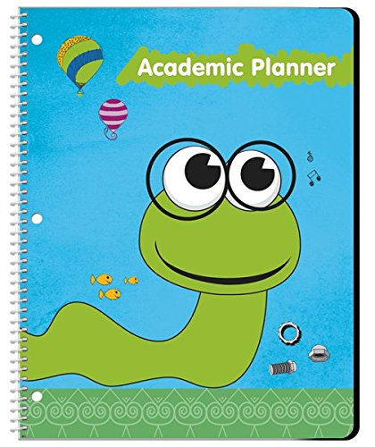

1 pair of Fiskar 5” scissors
3 composition notebooks
3 spiral notebooks- 70 pages wide rules
1 pencil box
1 clip board
1 small dry erase board
2 plastic pocket folders with brads
1 art drawing pad with blank pages
2 boxes of crayons - 24 ct.
Do not label the following:
6 erasers
1 box of non-toxic dry erase markers
2 boxes of kleenex
1 container of antibacterial wipes
2 paper towels
1 bottle of germ-x
Arabic Supplies List
1 package card stock (white)
2 notebooks
12 pencils
4 glue sticks
1 liquid glue
2 plastic folders
Arabic Supplies List
1 package card stock (white)
2 notebooks
12 pencils
4 glue sticks
1 liquid glue
2 plastic folders

Second Grade Supplies List
2018-2019 School Year

4 five star spiral notebooks (1 Subject)

1 Journal Notebook

1 pack of Flashcards
3 Plastic folders with pockets (1 yellow, 1 blue and 1 green)

2 1 inch binders with Showcase
1 boxes of crayons (24 count)

1 pack of Dry erase markers

1 Pencil Box
2 dozens #2 pencils
2 Pentel white Hi-Polymer erasers
1 box of (pencil-toppers) erasers
1 pair of scissors (pointed)
1 ruler ( 12 inch)
1 bottles of hand sanitizer (germ-x)
3 large boxes of Kleenex
2 roll of Bounty select- paper towels
3 bottle of Clorox wipes

Third Grade School Supplies list
2018-2019 School Year
10 Spiral Notebooks (One subject 70 pg.)
2 Composition notebooks
6 pocket folders (1 blue, 1 green, 1 yellow, 1 red, 1 black, 1 orange) with brads
1 One-and-1/2 inch binder with showcase
1 backpack (no rolling backpack please)
1 bottle of Elmer’s white glue
4 glue sticks
1 pack of dry erase markers
2 large art gum erasers
1 box of (pencil toppers) erasers
24 #2 pencils
1 box of crayons – 24 count
1 box of washable markers
1 box of Colored Pencils
1 pair scissors (pointed)
1 supply box with snap closure
1 Box ziploc baggies – quart size
1 bottle of germ-x
2 large boxes of Kleenex
2 boxes of Clorax wipes
3 rolls of Bounty select size paper towels
1 clipboard
Arabic Supplies List
2 index cards packages and 2 red pens

Fourth Grade School Supplies list
2018-2019 School Year

1 backpack (no rolling backpack please)
1 bottles of Elmer’s white glue
1 package glue sticks
1 box of dry erase markers
1 container of wet wipes (sanitization wipes-unscented)
5 pocket folders (1 blue, 1 green, 1 yellow, 1 red) with brads
1 package of Index card (100 count)
1 Protractor
2 art gum erasers
24 #2 pencils
1 box of crayons – 24 count
1 box of Crayola washable markers
1 box of Colored Pencils
1 pair Fiskar 5” scissors
3 composition notebooks
3 spiral notebooks – 70 pages (wide ruled)
1 supply box with snap closure
1 Box ziploc baggies – quart size- 55 count (boys only)
1 box Ziploc baggies – gallon size – 55 count (girls only)
2 clorax wipes
1 clipboard
1 flash/usb drive
Arabic Supplies List

1 index cards
2 index cards packages
2 red pens

Day Care Supplies List
2018-2019 School Year

- Diapers
- Baby Wipes
- Clorox Wipes
- Kleenex
- Paper Towel

Baby Bag

- Extra Clothes
- Pillow
- Blanket
- Sheet for Mat
- Sleeping Mat

