Pre k School Supplies List
2023-2024 School Year
• 1 School box
• 1 folder with inside pockets
• 1 box of markers
- 1 box of crayons
- 2 glue sticks
- 2 glue bottles (liquid)
- 2 Clorox wipes
- 2 paper towel rolls
- 2 box of Kleenex tissue
• Small blanket/sheet
• Small pillow
• Kinder Mat/ Nap Mat
• Full set of extra clothes, including socks and shoes.
Water bottle

Kg Supply List 2023-2024

(Supplies will be used in both homeroom and Arabic class.)

* Backpack, full size that will hold an 8½ x 11 folder
* Lunch box
* Water bottle
* 1 pencil box with snap closure
* 1 wide ruled notebook
* 1 half page ruled primary journal

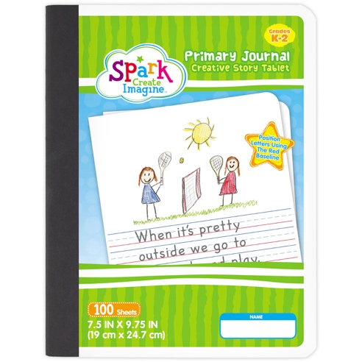
* 3 poly vinyl folders with center brads (1 red, 1 blue, 1
Green)
* 2 box washable markers
* 1 box of crayons (16 counts only)
* 1 watercolor set (Crayola brand only)
* 10 #2 pencils
* 2 pink erasers
* 8 glue sticks
* 4 dry erase markers (4 fine tip, 2 chisel tip)
* 4 containers of Play-Doh
* 2 tissue boxes

* 1 roll of paper towel
* 1 package of disinfecting hand wipes (girls only)
* 1 package of watercolor paper (girls only)
* 1 Ziploc box sandwich size (boys only)
* 1 package of white card stock (boys only)
* 1 white hijab for Salah

First Grade School Supplies List
2023-2024 School Year
(Supplies will be used by homeroom and QAIS class)

Please label the following:
*1 backpack +lunchbox
*1- 1” 3-ring binder with showcase view
*1 pencil snap box
*1 box of Crayola washable markers
*1 boxes crayons
* 1 pack of 4 glue sticks
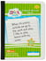
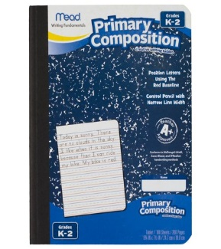
* 1 bottle of liquid Elmer’s glue
*1 art drawing pad with blank pages
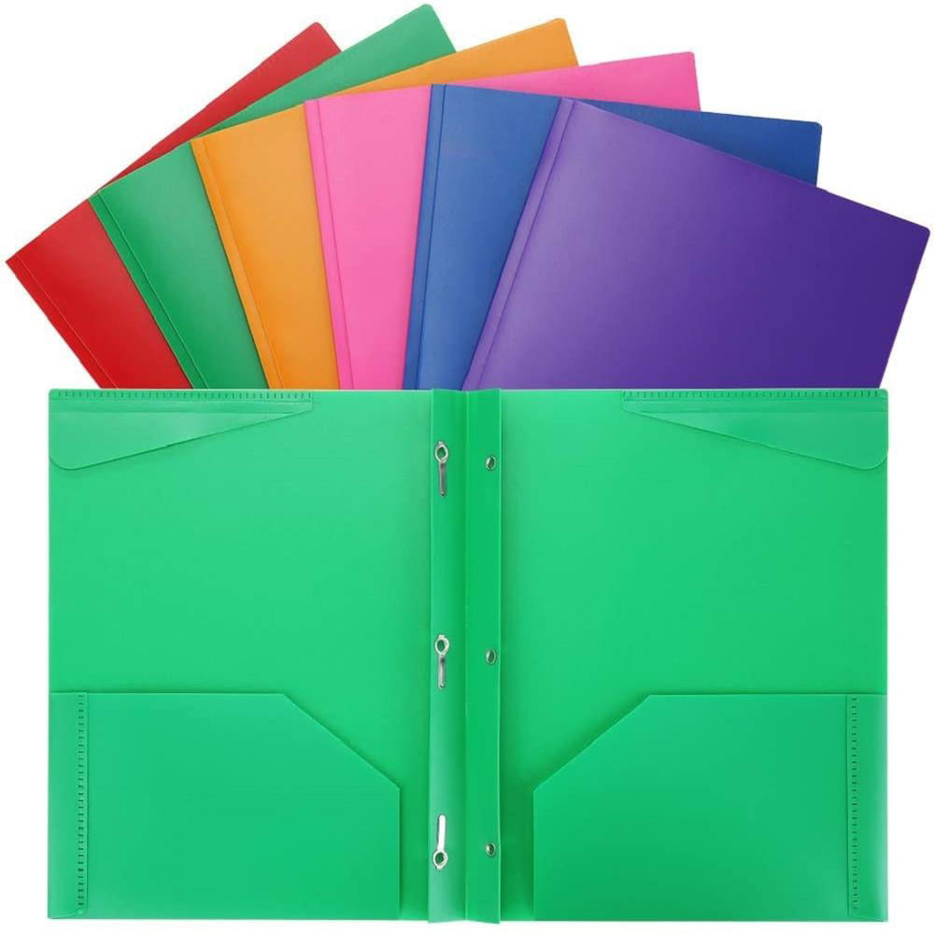
*1 pair of Fiskars 5” scissors
*4 composition notebooks
Ruled with baseline red
*4 plastic pocket folders with brads
(2-red, 2- green)
*Water bottle
* 1 pair of headphones to keep in class for QAIS
* 1 dry erase clipboard – white
* 1 white hijab for daily use

Do not label the following:
*6 erasers
*10 #2 pencils
*2 boxes of Kleenex
*2 container of Clorox wipes
*2 paper towels
*1 package white cardstock
* 1 package of white copy paper
* 1 Ziploc box freezer gallon bags (girls only)
* 1 Ziploc box quarter size bags (boys only)
* 1 big bottle of Hand Sanitizer

Supplies List
2nd Grade
Islamic School of Columbia Missouri
2023-2024 School Year
Personal Care:
- Tissue (travel size / small pack)
- Hand sanitizer (small travel size)
- An extra mask
- Water bottle
Science:
- Notebook
- Folder
- Index cards
Social Studies:
- Notebook
- Folder
Math:
- Folder
- Loose leaf paper
ELA (Spelling, Grammar/Writing, Reading):
- Three notebooks (Spelling, Grammar, Writing)
- Journal for writing
- Three folders (paper or plastic)
Other Supplies:
- Colored pencils
- Washable markers
- One glue stick
- Scissors
- Pencil box
- 2-3 pencils
- Erasers
- Ruler
- Pencil sharpener
- * 1 pair of headphones to keep in class for QAIS
- 1 white hijab for daily use

Third Grade School Supplies list
2023-2024 School Year

- 4 single-spiral notebooks (wide rule – 70 count)
- 1 blue, 1 yellow, 1 red, 1 green
- 6 double-pocket folders
- 1 blue, 1 yellow, 1 red, 1 green, 2 any color
- 2 composition notebook
- 1 pink eraser (can be another color, but make sure it’s good quality)
- 1 package of No. 2 pencils (12-pack)
- 1 pack of colored pencils
- 1 box of dry erase markers
- 1 pack of Crayola washable markers
- 2 glue sticks
- 1 ruler (metric and inches)
- 1 supply box with snap closure
- 1 backpack
- 1 transparent tape refills (to be used in the class tape dispenser)
- 2 family-sized Kleenex tissue boxes
- 2 clorox disinfecting wipes
- 2 rolls of paper towels
- 2 packs of loose leaf paper (wide ruled)
- 1 pencil sharpener
- 1 planner
- 1 binder (2-inch, black only. Please, no fancy binders!)
* 1 Ziploc box freezer gallon bags (girls only)
* 1 Ziploc box quarter size bags (boys only)
* 1 pair of headphones to keep in class for QAIS
* 1 white hijab for daily use
Arabic/ Islamic Studies
- 2 Spiral notebooks (wide rule 70 sheet)
- 1 Binder (1-inch binder)
- 1 Pack of construction papers
- 100 pc index cards
Personal Care:
- Tissue, travel size / small pack (keep one extra )
- Hand sanitizer, small travel size
- An Extra Mask
- Water Bottle

Fourth Grade School Supplies list
2023-2024 School Year

1 Backpack (no rolling backpack please)
1 Box of dry erase markers
6 Pocket folders (1 blue, 1 green, 1 yellow, 1 red, and 2 any color) with brads
1 Protractor
1 Pad of Post-It notes
1 Pencil sharpener
1 pink eraser (can be another color, but make sure it’s good quality)
1 Ruler (12 inches)
1 box of Crayola washable markers
1 Box of Colored Pencils
3 Composition notebooks
4 Spiral notebooks – 70 pages (wide ruled)
1 Supply box with snap closure
2 Kleenex/ facial tissue box
1 Flash/USB drive
1 Binder (2” Binder)
1 Watercolor paint
2 Rolls of Paper towels
2 Clorox disinfecting wipes
1 Planner
2 packs of loose-leaf paper (wide ruled)
1 headphone set to be kept in class
1 white hijab for daily use
Arabic/ Islamic Studies
- 2 Spiral notebooks (wide rule 70 sheet)
- 1 Binder (1-inch binder)
- Construction papers
- 100 pc index cards
Personal Care:
- Tissue, travel size / small pack (keep one extra)
- Hand sanitizer, small travel size
- An Extra Mask
- Water Bottle

Fifth Grade Supply List
2023-2024 school year
- 4 single-spiral notebooks (wide rule – 70 count)
- 1 blue, 1 yellow, 1 red, 1 green
- 6 double-pocket folders
- 1 blue, 1 yellow, 1 red, 1 green, 2 any color
- 2 composition notebooks
- 1 pink eraser (can be another color, but make sure it’s good quality)
- 1 packages of No. 2 pencils (12-pack)
- 1 yellow highlighter
- 1 pack of colored pencils
- 1 box of dry erase markers
- 1 pack of Crayola washable markers
- 1 ruler (metric and inches)
- 1 supply box with snap closure
- 1 backpack
- 1 transparent tape refills (to be used in the class tape dispenser)
- 2 family-sized Kleenex tissue boxes
- 2 Clorox disinfecting wipes
- 2 rolls of paper towels
- 2 packs of loose-leaf paper (wide ruled)
- 1 mini whiteboard
- 1 set of watercolor paints
- 1 pencil sharpener
- 1 flash/USB drive
- 1 planner
- 1 2-inch binder
- 1 clipboard
Arabic/ Islamic Studies
- 2 Spiral notebooks (wide rule 70 sheet)
- 1 Binder (1-inch binder)
- 1 Pack of construction papers
- 100 pc index cards
Personal Care:
- Tissue, travel size / small pack (keep one extra)
- Hand sanitizer, small travel size
- An Extra Mask
- Water Bottle
- 1 white hijab for daily use
Day Care Supplies List
2023-2024 School Year

- Diapers
- Baby Wipes
- Clorox Wipes
- Kleenex
- Paper Towel

Baby Bag

- Extra Clothes
- Pillow
- Blanket
- Sheet for Mat
- Sleeping Mat/ Kinder mat
- Water bottle
- Small backpack and lunchbox (for bigger kids)

