W~Daycare School Supplies List
2023-2024
Baby Bag/Back pack
- diapers
- baby wipes
- 1 full set of extra clothes, including socks and shoes.
- lunchbox (for toddlers)
- water bottle

Classroom
- 1 package of disinfecting hand wipes
- 2 paper towel rolls
- 1 box Kleenex tissue
- 1 small pillow
- 1 Kinder Mat/ Nap Mat
- 1 sheet for Kinder Mat/ Nap Mat

Pre-K School Supplies List
2023-2024
- 1 school box
- 1 folder with inside pockets
- 1 box of markers
- 1 box of crayons
- 2 glue sticks
- 2 Glue All bottles (liquid)
- 2 Clorox wipes
- 2 paper towel rolls
- 2 family size boxes of Kleenex tissue
- 1 small blanket/sheet
- 1 small pillow
- 1 Kinder Mat/ Nap Mat
- 1 full set of extra clothes, including socks and shoes.
- 1 water bottle

Kindergarten School Supplies List
2023-2024
Supplies will be used for both homeroom and QAIS classes.
- 1 backpack, full size that will hold an 8½ “ x 11” folder
- 1 lunch box
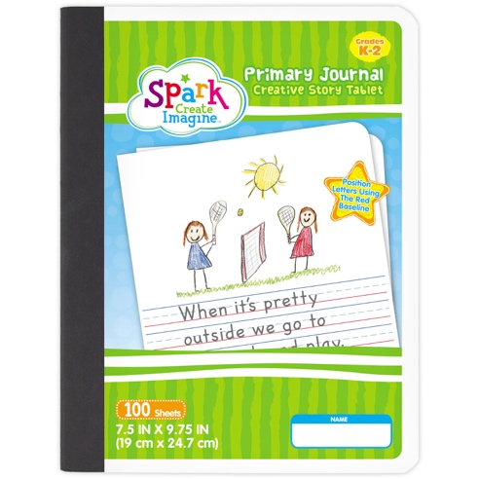
- 1 water bottle
- 1 pencil box with snap closure
- 1 wide ruled notebook
- 1 half page ruled primary journal (example shown)
- 3 poly-vinyl folders with center brads
(1 red, 1 blue, 1 green)
- 2 boxes washable markers
- 1 box of crayons (16 counts only)
- 1 watercolor set (Crayola brand only)
- 10 #2 pencils
- 2 large pink erasers
- 8 glue sticks
- 6 dry erase markers (4 fine tip, 2 chisel tip)
- 4 containers of Play-Doh
- 2 family size tissue boxes
- 1 roll of paper towels
- 1 box Ziploc bags, sandwich size (boys only)
- 1 package of 8.5” x 11” white card stock (boys only)
- 1 package of disinfecting hand wipes (girls only)
- 1 package of watercolor paper (girls only)
- 1 white hijab for daily use (girls only)

First Grade School Supplies List
2023-2024
Supplies will be used for both homeroom and QAIS classes.
Please label the following with your STARR’s First and Last Name:
- 1 backpack + lunchbox
- 1 water bottle
- 1 pair of headphones to keep in class for QAIS
- 1 white hijab for daily use (girls only)
- 1 dry erase/clipboard – white
- 1- 1” 3-ring binder with showcase view
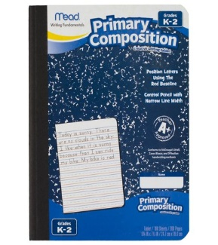
- 1 pencil box with snap closure
- 1 box of Crayola washable markers
- 1 box of crayons
- 1 pair of Fiskars 5” scissors
- 4 glue sticks
- 1 bottle of liquid Elmer’s glue
- 1 art drawing pad with blank pages
- 4 composition notebooks ruled with baseline red
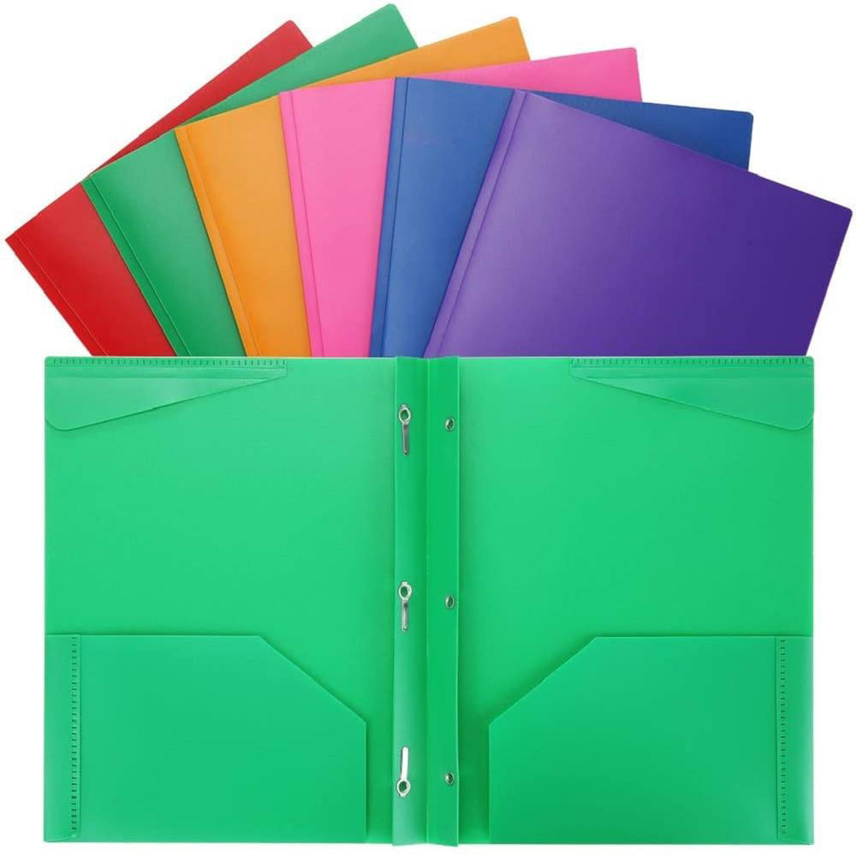
- 4 plastic pocket folders with brads
(2- Red, 2- green)

Do not label the following:
- 6 large pink erasers
- 10 #2 pencils
- 2 family size tissue boxes
- 1 large bottle of hand sanitizer
- 2 containers of Clorox wipes
- 2 rolls of paper towels
- 1 package of 8.5” x 11” white card stock
- 1 package of white copy paper
- 1 box of Ziploc freezer gallon bags (girls only)
- 1 box of Ziploc quart size bags (boys only)
Second Grade School Supplies List
2023-2024
Supplies will be used for both homeroom and QAIS classes.
Personal Care:
- 1 tissue (travel size / small pack)
- 1 hand sanitizer (small travel size)
- 1 extra mask
- 1 water bottle
- 1 backpack + lunch box
- 1 pair of headphones to keep in class for QAIS
- 1 white hijab for daily use (girls only)
Other Supplies:
- 4 composition notebooks (Spelling, Grammar, Writing & Journal)
- 2 spiral notebooks (wide rule-70 sheet)
- 6 double pocket folders
- 1 package of 100 pc index cards
- 1 package loose leaf wide-ruled paper
- 1 box colored pencils
- 1 box washable markers
- 1 glue stick
- 1 pair Fiskars 5” scissors
- 1 pencil box with snap closure
- 3 pencils
- 3 large erasers
- 1 ruler (metric and inches)
- 1 Pencil sharpener
Third Grade School Supplies List
2023-2024
Supplies will be used for both homeroom and QAIS classes.
- 1 school planner
- 1 binder (2-inch, black only. Please, no fancy binders!)
- 1 Binder (1-inch) any color
- 6 single-spiral notebooks (wide rule – 70 sheet)
- 1 blue, 1 yellow, 1 red, 1 green, 2 any color
- 6 double-pocket folders
- 1 blue, 1 yellow, 1 red, 1 green, 2 any color
- 2 composition notebooks
- 2 packages loose leaf wide-ruled paper
- 1 package construction paper
- 1 package 100 pc index cards
- 1 large pink eraser (can be another color, but make sure it’s good quality)
- 1 package of No. 2 pencils (12-pack)
- 1 pencil box with snap closure
- 1 pencil sharpener
- 1 box of colored pencils
- 1 box of dry erase markers
- 1 pack of Crayola washable markers
- 2 glue sticks
- 1 ruler (metric and inches)
- 1 transparent tape refills (to be used in the class tape dispenser)
- 2 family-sized Kleenex tissue boxes
- 2 containers of Clorox disinfecting wipes
- 2 rolls of paper towels
- 1 Ziploc box freezer gallon bags (girls only)
- 1 Ziploc box quart size bags (boys only)

Personal Care:
- 1 Tissue (travel size / small pack)
- 1 Hand sanitizer (small travel size)
- 1 extra mask
- 1 water bottle
- 1 backpack + lunch box
- 1 pair of headphones to keep in class for QAIS
- 1 white hijab for daily use (girls only)

Fourth Grade School Supplies List
2023-2024
Supplies will be used for both homeroom and QAIS classes.
- 1 backpack + lunch box (no rolling backpacks please)
- 1 planner
- 1 binder (2 inch)
- 1 binder (1 inch)
- 7 pocket folders (1 blue, 1 green, 1 yellow, 1 red, and 3 any color) with brads
- 3 composition notebooks
- 6 spiral notebooks – 70 pages (wide ruled)
- 2 packs of loose-leaf paper (wide ruled)
- 1 package construction paper
- 1 package 100 pc index cards
- 1 protractor
- 1 ruler (12 inches/30 cm)
- 1 pad of Post-It notes
- 1 pencil sharpener
- 1 package of No. 2 pencils (12-pack)
- 1 pink eraser (can be another color, but make sure it’s good quality)
- 1 pencil box with snap closure
- 1 box of dry erase markers
- 1 box of Crayola washable markers
- 1 box of colored Pencils
- 1 set of watercolor paints
- 2 family-sized Kleenex tissue boxes
- 2 rolls of paper towels
- 2 containers of Clorox disinfecting wipes

Personal Care:
- 1 Tissue (travel size / small pack)
- 1 Hand sanitizer (small travel size)
- 1 extra mask
- 1 water bottle
- 1 pair of headphones to keep in class
- 1 Flash/USB drive
- 1 white hijab for daily use (girls only)

Fifth Grade School Supplies List
2023-2024
Supplies will be used for both homeroom and QAIS classes.
- 1 planner
- 1 binder (2 inch)
- 1 binder (1 inch)
- 6 single-spiral notebooks (wide rule – 70 count)
- 1 blue, 1 yellow, 1 red, 1 green, 2 any color
- 7 double-pocket folders
- 1 blue, 1 yellow, 1 red, 1 green, 3 any color
- 2 composition notebooks
- 2 packs of loose-leaf paper (wide ruled)
- 1 pink eraser (can be another color, but make sure it’s good quality)
- 1 packages of No. 2 pencils (12-pack)
- 1 pencil sharpener
- 1 pencil box with snap closure
- 1 yellow highlighter
- 1 pack of colored pencils
- 1 box of dry erase markers
- 1 pack of Crayola washable markers
- 1 set of watercolor paints
- 1 ruler (metric and inches)
- 1 transparent tape refills (to be used in the class tape dispenser)
- 2 family-sized Kleenex tissue boxes
- 2 Clorox disinfecting wipes
- 2 rolls of paper towels
- 1 mini whiteboard
- 1 clipboard
Personal Care:
- 1 Tissue (travel size / small pack)
- 1 Hand sanitizer (small travel size)
- 1 extra mask
- 1 water bottle
- 1 backpack + lunch box
- 1 pair of headphones to keep in class
- 1 flash/USB drive
- 1 white hijab for daily use (girls only)

